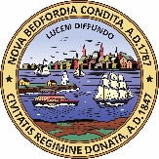
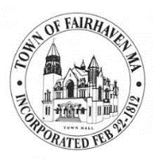
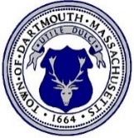
Greater New Bedford Regional
Refuse Management District
www.gnbrrmdistrict.org

Town of Fairhaven
City of New Bedford

Town of Dartmouth
PRESS RELEASE
FOR IMMEDIATE RELEASE
Date: July 28, 2021
Contact: Marissa Perez-Dormitzer, Waste Reduction Manager
Phone: (508) 979-1493
Email: Marissa@gnbrrmdistrict.org

Paper Shredding Day Taking Place
August 14 in Fairhaven

Fairhaven, Massachusetts – A summer Paper Shredding Day will take place on Saturday, August 14, 2021, from 9 a.m. to noon* in Fairhaven. It will be a contactless event to keep both participants and staff safe. All are welcome; there is no residency requirement.
“Identity theft is a growing concern. Everyone must be vigilant in protecting personal information. Shredding your documents is an excellent way to protect yourself and your family, NBCU is proud to sponsor these community shredding days.” said Kelly Machado, Marketing Manager for NBCU. If you cannot make this event, look for the future dates on nbcu4u.com.
The shredding event will be held at the Hastings Middle School, 30 School Street, Fairhaven. When each participant reaches the shred truck, staff will remove boxes from the trunk of your vehicle, empty them into a recycle bin, and return boxes to participants. The recycle bin is emptied into the Shred-it truck. Shred-it is certified by the National Association for Information Destruction and adheres to their stringent security practices and procedures. For safety purposes, participants are not able to watch the destruction of their paper.
Individuals may bring up to two boxes of paper. The shred truck can only take a certain amount of paper, so the limit of two boxes allows Paper Shredding Day to serve more people. The event will end when the shred truck is full; it is possible it may be before noon. Each box should weigh no more than 30 to 40 pounds. Paper clips and staples do not need to be removed, but please remove paper from folders and binders.
Shredding confidential documents helps to prevent identify theft, protect personal information, and prevent valuable resources from being sent to the landfill. The shredded paper will be recycled into new products such as paper towels.
Event is sponsored by NBCU and held in partnership with the Town of Fairhaven, the City of New Bedford, the Town of Dartmouth, and the Greater New Bedford Regional Refuse Management District.
For more information, please visit gnbrrmdistrict.org, call the Greater New Bedford Regional Refuse Management District at (508) 979-1493, or email Marissa@gnbrrmdistrict.org.
###

